Presentation of Ralph Sutter; 01/05/2020
Alexa and Home Automation
I have two Amazon Echo devices in my home, the original First Generation model $99.99 as I recall
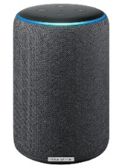
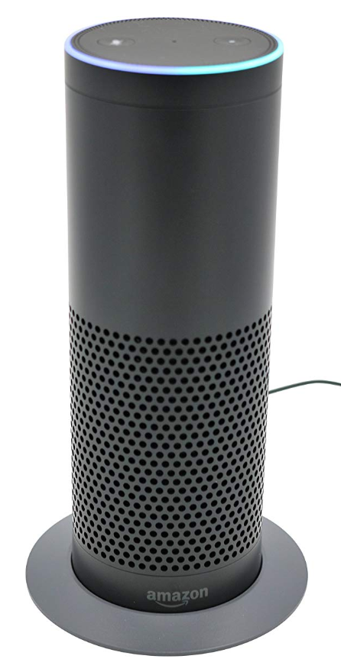and a recently purchased Third Generation one; $79.99. This latter Echo device has an Input/Output jack not found in the First Generation device and necessary for sending Echo’s output through my home entertainment center.
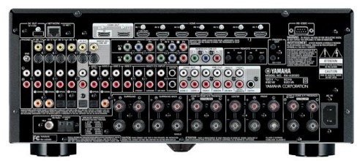
I connected the Third Generation Echo device to my Yamaha Home Entertainment Receiver (purchased in 2014)
https://www.crutchfield.com/S-PCMYkCru7Vh/p_022RXA2020/Yamaha-RX-A2020.html
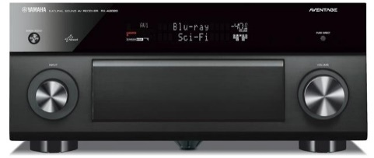

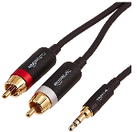
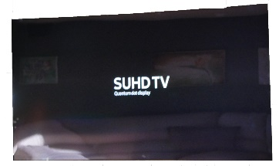
using an AmazonBasics 3.5mm to 2-Male RCA Adapter Audio Stereo Cable - 8 Feet; $8.99 and plugging the cable in to the second AV input.
The receiver is in turn connected to a Samsung 55" Class (54.6" Diag) 4K SUHD Curved LED $1279.99 purchased 01/10/2017
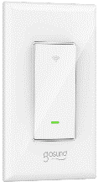

I added a Gosund Smart Switch; $17.99
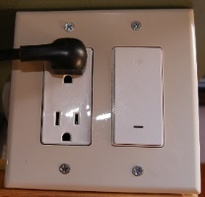
and installed the smart switch in an electrical box so that I could readily move it from one location to another.
I then plugged the TV into the box.
My goal was to be able to use the Amazon Echo device in my Den to turn on the TV. This was more a proof of concept than a pressing need. I managed to accomplish that feat. The following links show the steps required.

My demo of the Gosund Smart Switch and the Alexa Skill;
https://www.slobytes.org/presentations/sutter-0120/sutter-wifi-demo.mp4

Procedure for setting these devices up
Download and install the Smart Life app from the iPhone App Store or Google Play Store depending your Smart Phone
Complete instructions for setup are available from Gosund ks-602s Smart Wall Light Switch User Manual

See a YouTube Installation Video that includes setup with Amazon Echo at https://www.youtube.com/watch?v=AZ7AX_bFgEE

For a comprehensive list of the capabilities of the Amazon Echo Device, see
Tom’s Guide to Amazon Echo
https://www.tomsguide.com/us/how-to-use-alexa,review-3488.html
Gosund Wi-Fi Enabled Plugs; $31.99 for Four
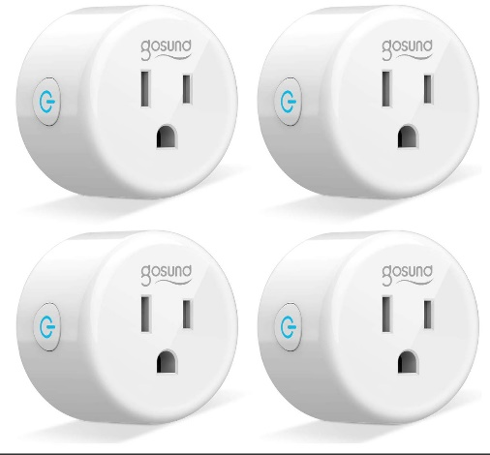
https://www.amazon.com/gp/product/B07GRLQV47/ref=ppx_yo_dt_b_asin_title_o01_s00?ie=UTF8&psc=1

